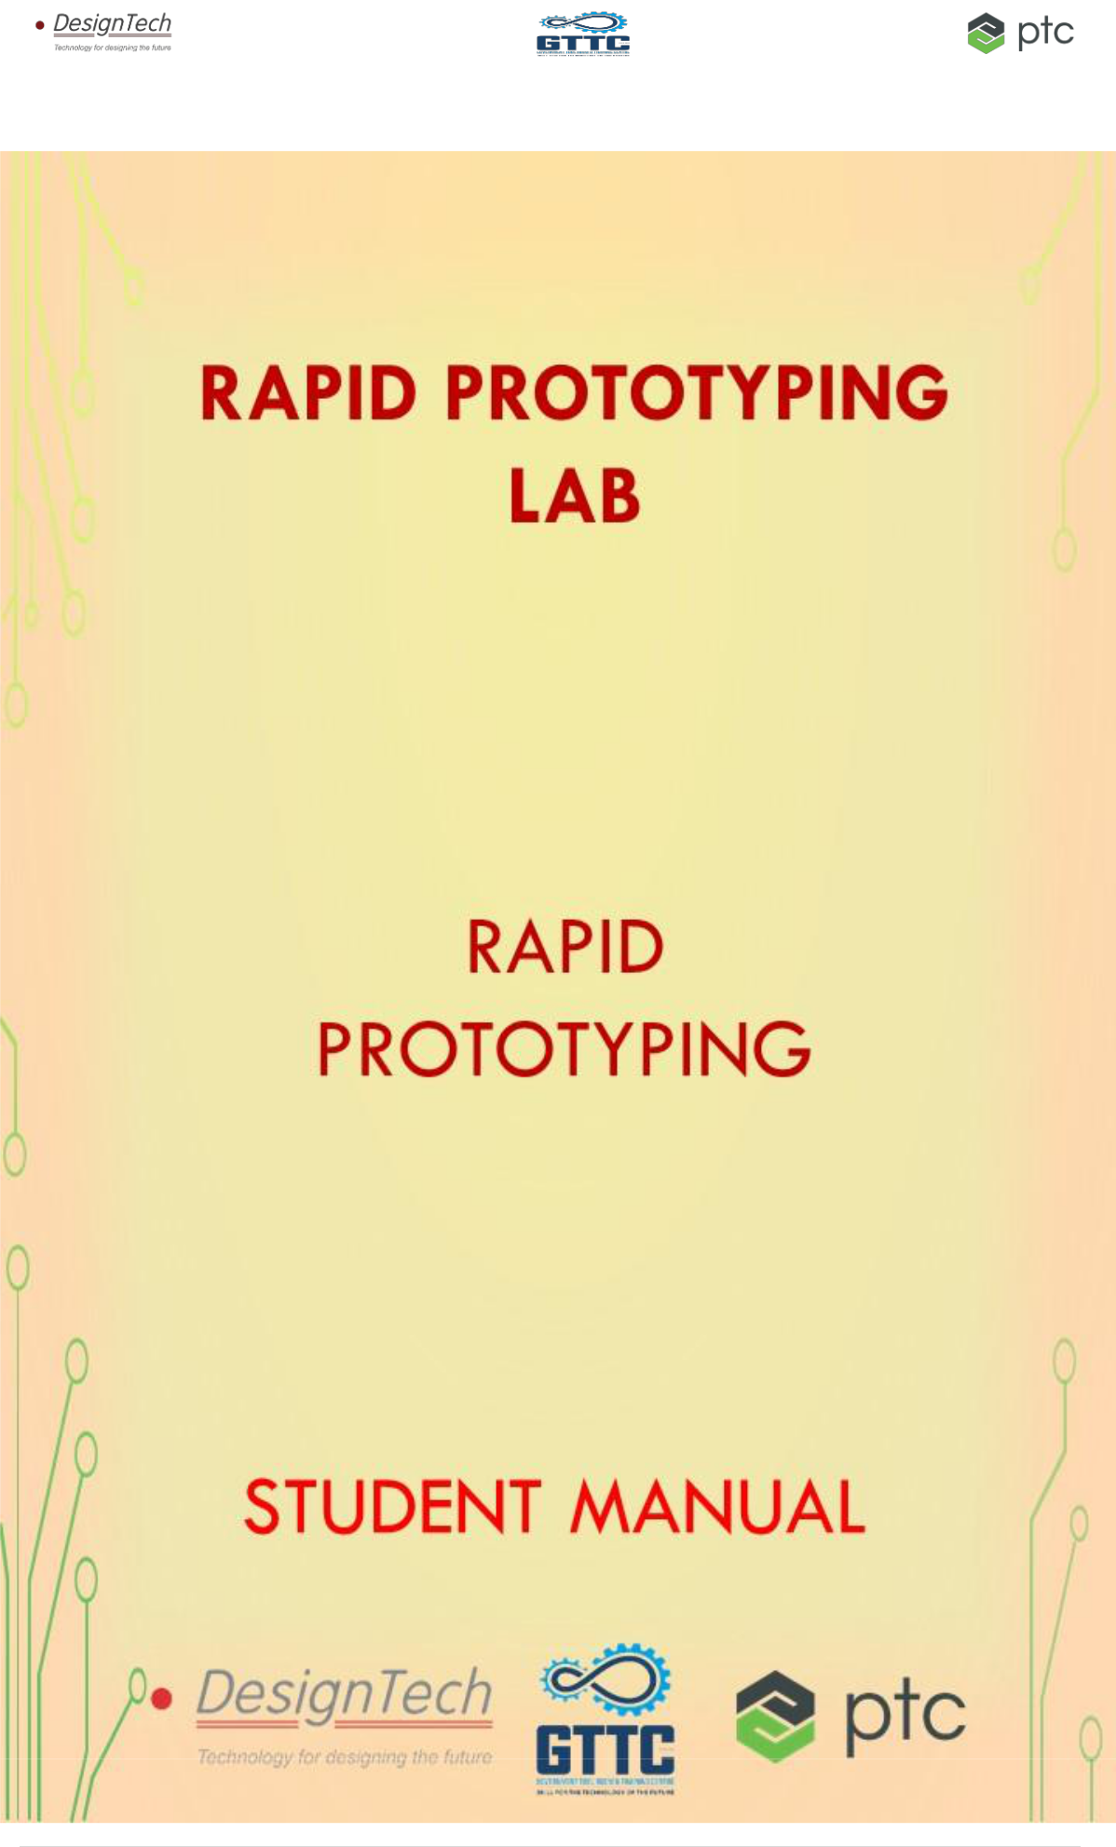

1 | P a g e



RAPID PROTOTYPING LAB

This lab allows you to visualize your imagination in a real environment and which

can be further developed and optimized. PTC Creo, Grab CAD and Object Studio

software packages are used to achieve this and which helps you to save time, money and

effort to develop new product.
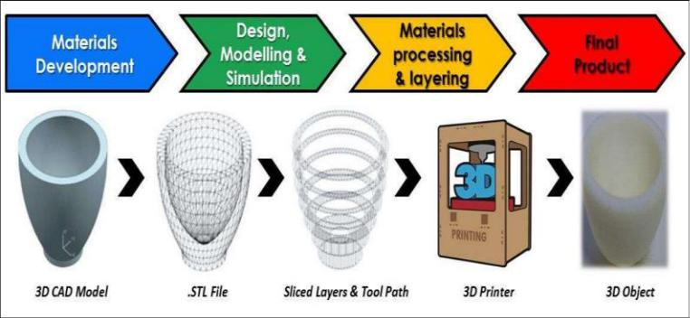

In this lab you will be learning different types of rapid prototyping technologies like solid based (Laminated Object Manufacturing and Fused deposition modelling), Liquid based (Stereo lithography, Droplet deposition modelling) and Powder based (Selective laser sintering). How to communicate with the 3D printing machine and also printing some models.

The list of courses offered,

 | Sr. |  |  | Title of the courses |  |  | Hours
 | No.
 | 1. |  |  | Rapid Prototyping |  |  | 16
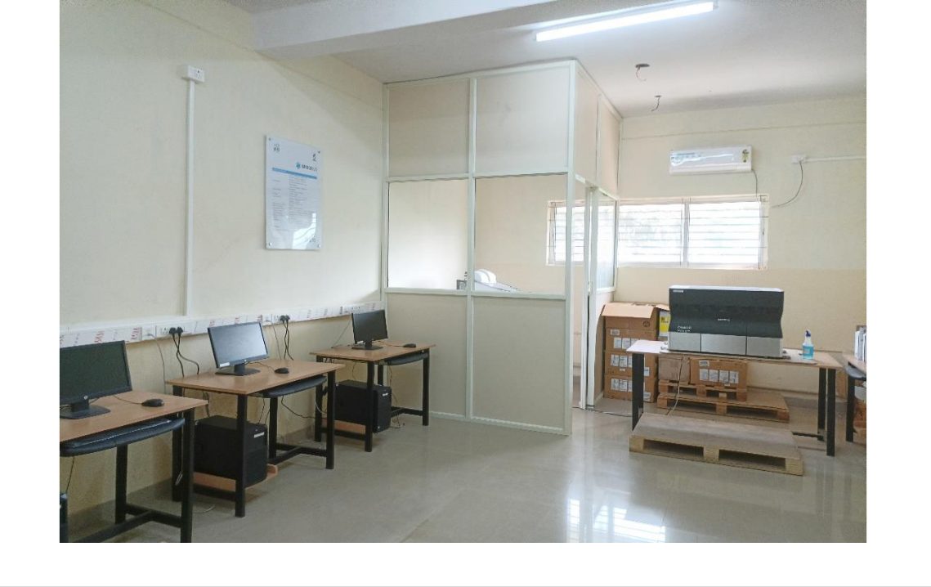

2 | P a g e
Rapid Prototyping

Rapid prototyping is a group of techniques used to quickly fabricate a scale model of a physical part or assembly using three-dimensional computer aided design (CAD) data. Construction of the part or assembly is usually done using 3D printing or "additive layer manufacturing" technology.

The first methods for rapid prototyping became available in the late 1980s and were used to produce models and prototype parts. Today, they are used for a wide range of applications and are used to manufacture production-quality parts in relatively small numbers if desired without the typical unfavorable short-run economics. This economy has encouraged online service bureaus. Historical surveys of RP technology start with discussions of simulacra production techniques used by 19th-century sculptors. Some modern sculptors use the progeny technology to produce exhibitions. The ability to reproduce designs from a dataset has given rise to issues of rights, as it is now possible to interpolate volumetric data from one-dimensional images.

 | S. No |  | Name of the Course |  | Duration

1

Creo for Design

108 Hours

HARDWARE
- RPT Machine

- Water Jet Machine

SOFTWARE PACKAGES
- Creo parametric 6.0.3.0

- Object Studio or Grab CAD
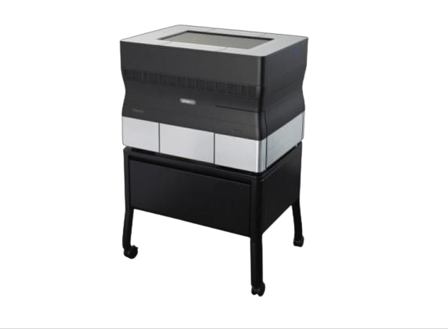

3 | P a g e

Table of Contents

Manufacturing processes 5

Introduction to Rapid prototyping 6

History of Rapid prototyping 7

Steps in Rapid prototyping process 8

Classification of Rapid prototyping processes 10

Liquid based Rapid prototyping techniques 10

Solid based Rapid prototyping techniques 11

Powder based Rapid prototyping techniques 11

Selection of rapid prototyping systems 12

Stereolithography 13

Solid ground curing 14

Droplet deposition manufacturing 15

Fused deposition modelling 16

Laminated object manufacturing 17

Selective laser sintering 18

Laser engineered net shaping 19

Three dimensional powder binding 20

Advantages and limitations 21

Advantages of rapid prototyping 21

Limitations of rapid prototyping 22

Applications of 3D printing 23

Introduction to objet studio software 25

Objet 30 prime 3D printer 26

4 | P a g e
Manufacturing processes

Word manufacturing refers to conversion of raw materials into finished components.
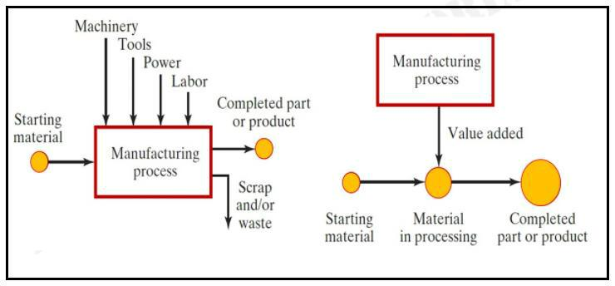

To make any thing we have number of manufacturing processes. Basically they are devided into 5 categories.

- Casting

- Machining or material removing

- Joining

- Forming

- Rapid prototyping

Rapid prototyping method accelerates the manufacturing field, reducing the manufacturing cost and lead times. Rapid prototyping systems offer opportunities to make the production faster at lower costs, with high dimensional accuracy influenced by machine parameters. The selection of appropriate rapid prototyping process depends upon the machine parameters, geometry of the part to be fabricated, its properties and the application of the part or product.

5 | P a g e
Introduction to Rapid prototyping
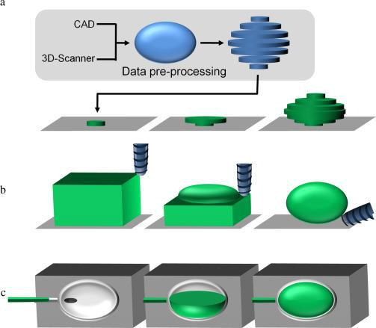

Rapid prototyping is a group of technologies used to quickly fabricate a scale model of a physical part or assembly using its digital blueprint. Construction of the part or assembly is usually done using 3D printing or additive layer by layer manufacturing technology.

3D printing is an iterative approach to user interface design that includes prototyping, reviewing, and refinement stages. Designers go through each step and, when they finish, they return to the starting (over and over again) until they have the result that satisfies initial expectations.

Rapid prototyping helps you to create multiple scaled models of your idea to further clarify the manufacturing process. Also, rapid prototypes can serve as dummy models to help represent your idea.

Rapid prototyping is an agile technology used during the product development process. With this approach, 3-dimensional prototypes of a product or part are created and tested to optimize characteristics like shape, dimension, and overall usability.

6 | P a g e
History of Rapid prototyping

The history and development of 3D printing starts from two main preceding techniques, topography, and photo sculpture. Originating in early 19th century, these processes were initially very laborious. They later evolved to more modern techniques used in topography and metallurgy that resemble some current processes of rapid prototyping. These two techniques set the foundation for rapid prototyping as we know it today. Hideo Kodama from Japan and Charles Hull from the USA were the first to describe and develop a process and actual machines that were capable of printing in 3 dimensions (3D) and are considered the fathers of modern rapid prototyping. Rapid prototyping has evolved over time from a previously widely unknown field, to one with a broad range of applications from building bridges to printing human organs.

Rapid prototyping is most advanced manufacturing process. First rapid prototyping machine came in the markets in the late 1980s. The early 3D printing process derived its name from the activities and the purpose for which the earlier 3D printers were used.

Stereolithography was the first patented technique. First 3D printer working on this technique machines came to market in 1984. This rapid prototyping technology makes it possible to cure layers of liquid monomer that are sensitive to ultraviolet light, with the help of laser technology. In upcoming decades after 1984, other 3D printing techniques emerged, e.g. Fused deposition modeling (FDM) and selective laser sintering. The first-ever 3D rapid prototyping system based on FDM technology was introduced in the 1990s. The latest development in rapid prototyping, the 3D printer, was launched in the 2000s.

1980: First patent by Japanese Dr Kodama for Rapid prototyping

1984: Stereolithography by French then abandoned

1986: Stereolithography taken up by Charles Hull, founder of 3D Systems

1988: Carl Deckard brought a patent for the SLS technology,

1988: Scott Crump, a co-founder of Stratasys Inc. filed a patent for FDM

7 | P a g e
Steps in Rapid prototyping process

All Rapid prototyping technologies have 5 steps to be employed to build model.

- Creation of CAD model

- Conversion of CAD model into .stl format

- Slicing of stl files into cross sectional layers

- Construction of model layer by layer

- Clean and finish the model
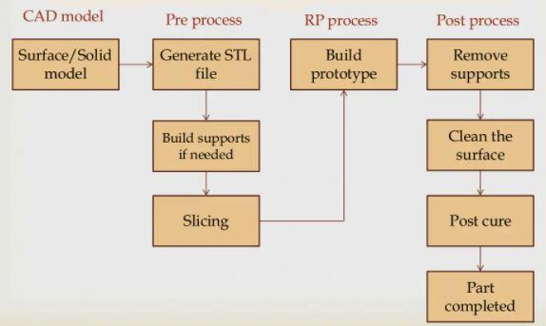

The process starts with a valid solid model in CAD that represents the part design. CAD model is digital information regarding shape, geometry and dimensions of the part. With the help of parametric CAD modeling software like CATIA, UG NX, CREO Parametric one can prepare CAD model.

3D printer may not support digital format od CAD data. After creation CAD model is converted into 3D printer supported format. To establish consistency, the STL format has been adopted as the standard by the rapid prototyping industry. The second step, therefore, is to convert the CAD file into STL format. This format represents 3D boundary geometry of an object as an assembly of triangular facets. The .stl file contains the

8 | P a g e
Cartesian co-ordinates of the vertices and the direction of the outward vector of each triangle.
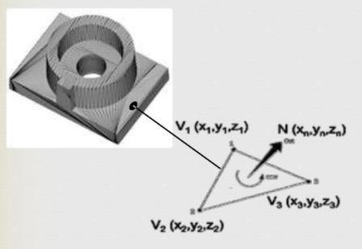

In next step this STL file is feed to pre-processing program of 3D printer. This program divides STL file in to number of layers having thickness from 0.01mm to 0.7mm depending upon 3D printing method. It also generates support material structure to support the model during build. It is useful to support overhangs, internal cavities, thin walls etc.

Next step is actual construction of model. 3D printer deposits layers that consists of polymer, paper, or powdered material. Very little human intervention is needed during this process.

Last step in Rapid prototyping process is post processing. In this step model from 3D printer is removed and support material is detached from model. Some photosensitive materials need to be fully cured before use. They may also require cleaning and surface treatments in some cases. Finally, to improve appearance and durability processes like sanding, sealing, coating or painting are employed.

9 | P a g e
Classification of Rapid prototyping processes

Although there are number of technologies for 3D printing, basic principle is same for all and it is bottom to up layer by layer fabrication. Based on the form of raw material supplied we can categorise rapid prototyping techniques into 3 groups.

- Liquid based 3D printing processes

- Solid based 3D printing processes

- Powder based 3D printing processes

All above processes require STL file converted from CAD model to be sliced into number of layers.

Liquid based Rapid prototyping techniques

Liquid based 3D printing systems have raw material in liquid phase. The raw material can include resin or polymer. Liquid based rapid prototyping systems works on the principle of Photo polymerisation process or photo curing under which three methods are possible

- Single laser beam method

- Masked lamp method

- Ultraviolet light method
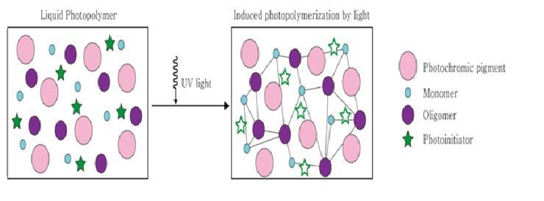

Liquid based rapid prototyping technologies print model in a vat of photo-curable resin, resin that cures under the exposure to laser or ultraviolet radiation. The laser cures the resin near the surface, forming a hardened layer. The formed layer is lowered by an

10 | P a g e
elevation control system to allow the next layer of resin to be similarly formed over it.

This continues until the entire part is completed.

Solid based Rapid prototyping techniques

In these systems raw material supplied is in solid phase. e. The solid form can include the shape in the form of a wire, laminate, pellets or a roll. Solid-based rapid prototyping systems works on the following principles:

- Cutting and Gluing / Joining method.

- Melting and Solidifying / Fusing method.

These processes are different from one another, though some of them use the laser in the process of fabricating prototypes. They all utilize solid in one form or the other, as the primary medium to create a prototype.

Powder based Rapid prototyping techniques

Powder particles are by-and-large to the particles of solid state in a strict context. However, intentionally it is categorized outside the solid-based rapid prototyping systems to refer powder in grain form. Parts are produced by fusing or binding thin slice of powdered material with the help of layer or binding material. All the powder based rapid prototyping systems works on the principle of Joining/Binding. The method of joining / binding differs for all the systems, in that some employ a laser while others use a binder/glue to achieve the joining effect. Binder material is deposited on to selected regions of layer of powder particles to produce a layer of powder particles that are completely bonded at the selected regions. Iterations would fabricate the desired part. Post-processing is highly required to remove the unbounded powder particles.

11 | P a g e
Selection of rapid prototyping systems

Large number of 3D printing technologies are available therefore it has created a problem of adopting the most feasible method to suit the requirement. The selection of appropriate rapid prototyping system can be done on the basis of a quantitative analysis.

The layer height for stereo lithography apparatus (SLA) and selective laser sintering (SLS) are same, but the layer height differs for fused deposition modelling (FDM). Thus, SLA and SLS can be compared like for like, whereas FDM has to be considered when comparing results.

Process parameters influence the accuracy of the part fabricated. Also the interactions of process parameters influence the dimensional accuracy of the fabricated component. Parameters such as raster width, path speed, slice height, and tip dimension at two different levels must be taken into consideration to determine the influence of these process parameters and their interactions on the dimensional accuracy of the part fabricated. Rapid prototyping systems may involve large number of contradictory factors that majorly influence the accuracy during the fabrication of the component. A standardized methodology of optimization is used to determine the optimum level settings for the part fabrication. Thus, experimental and numerical analysis reveals that the control of the process parameters of the machine at appropriate levels, improves the dimensional accuracy of the fabricated component or part.

Choosing the appropriate 3D printing process for a particular application is done by the parameters, orientation for printing the object, printing cost, manufacturing time, dimensional accuracy, and surface finish. The printing cost is the primary optimization objective. Volumes of printing inaccuracy, surface finish, manufacturing time are the secondary optimization objectives.

Part orientation for the part fabrication depends on the surface finish, support structure, shrinkage, print time, curing and cost. A support system is required to facilitate the selection of appropriate print direction as well as the best suitable 3D printing process. The three major factors in determining the best part orientation are the print time, surface roughness, and part cost. A multi-criterion decision-making method is taken into consideration in order to choose the best part orientation.

12 | P a g e
Stereolithography
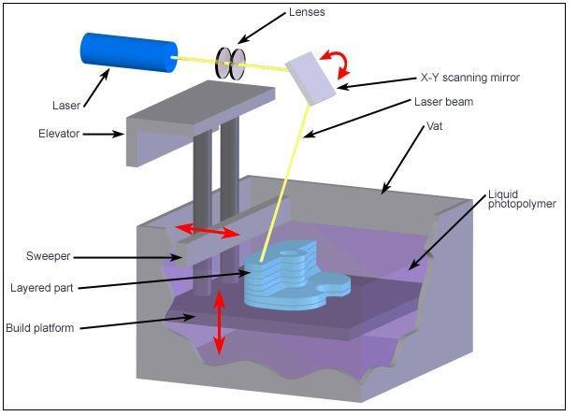

Stereo lithography is a Rapid prototyping technology used for creating models, in a layer by layer manner using photochemical processes by which light causes chemical monomers and oligomers in liquid phase to cross-link together to form solid polymers. It uses a bath of photosensitive liquid which is solidified layer-by-layer using a computer-controlled ultra violet (UV) light. This fast and affordable technique was the first successful method of commercial rapid prototyping.

Stereo lithography is widely employed for printing accurate 3D models of anatomical regions of a patient. It is also used in concept models and scale models.
- Benefits of Stereo lithography

  - Fair price

  - Good surface finish

  - Easily duplicates complex geometries

Stereo lithography is an excellent choice for rapid prototyping and project designs that require the production of very accurate and finely detailed parts. It’s ideal for producing show-and-tell parts to enable the validation of concept ideas and ergonomic testing.

13 | P a g e
Solid ground curing
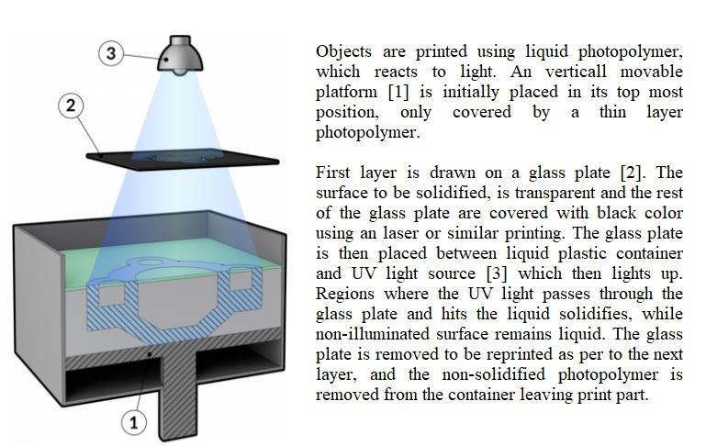

Solid ground curing is a photo-polymer-based additive manufacturing technology used for producing models, in which the production of the layer geometry is carried out by means of a high-powered UV lamp through a mask.

The main advantage of the solid ground curing system is that it does not require a support structure since wax is used to fill the voids, highly accurate products can be obtained The model produced by SGC process is comparatively accurate in the Z-direction because the layer is milled after each light-exposure process. Although it offers good accuracy coupled with high throughput, it produces too much waste and its operating costs are comparatively high due to system complexity.

14 | P a g e
Droplet deposition manufacturing
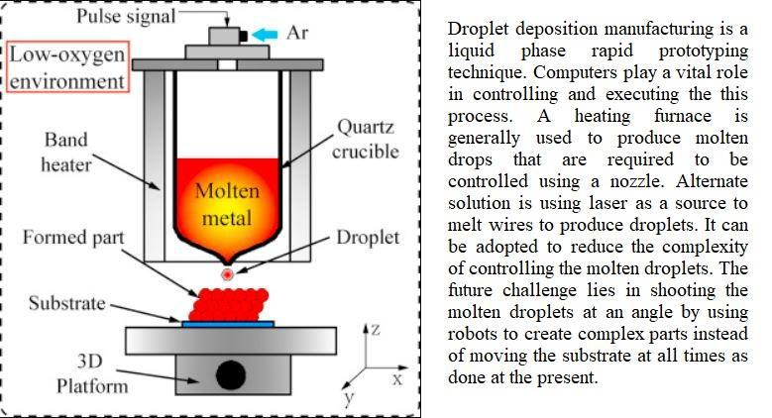

In the process of droplet deposition manufacturing first, the CAD model of object designed is transformed into Stereo-Lithography (STL)format, then, the STL model is feed into the slice software and sliced into a series of parallel layers with a certain layer thickness. Meanwhile, the solid areas in a layer are filled by droplet deposited paths, and the CNC file including droplet deposited path and co-ordinately control instructions is generated by slice software. Finally, the experimental system controls the spraying of droplets and the motioning of the deposition platform according to the CNC file, and the metal part with desired geometry can be fabricated by sequentially depositing metal droplets layer by layer.

15 | P a g e

Fused deposition modelling
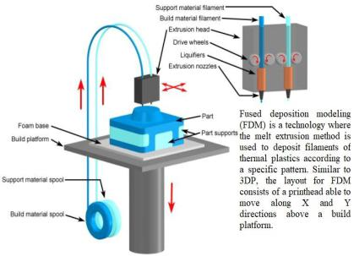

The Fused Deposition Modelling (FDM) process constructs three-dimensional objects directly from 3D CAD data. A temperature-controlled built head deposits thermoplastic material layer by layer. The FDM process starts with importing an STL file of a model into a pre-processing software. This model is oriented and divided into number of layers having thickness varying from 127 - 254 microns. A support structure is added where it is needed to support hanging portion and cavities. After reviewing the path data and generating the toolpaths, the data is sent to the 3D printer.

The system operates in X, Y and Z axes, drawing the model one layer at a time. The extrusion head is supplied with thermoplastic modelling material that is heated to a semi-liquid state. The head extrudes and directs the material with precision in very thin layers onto a base platform. The result of the solidified material joined to the preceding layer is a plastic 3D model. Once the part is completed the support material is removed and the surface is finished.

16 | P a g e
Laminated object manufacturing
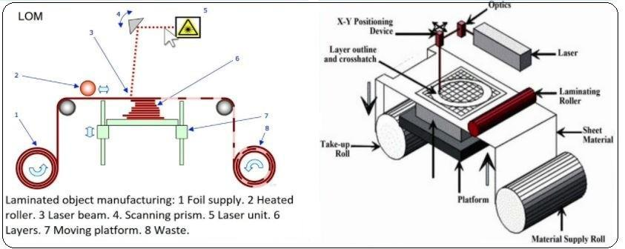

Laminated object manufacturing is a less famous 3D printing process where an object is created by successively combining foils of build material, bonding them through heat and pressure and then cutting them into the desired shape using either a blade or laser.

Main use of LOM-printers is printing of architectural models. It is also used in education and design, as it enables one to print objects with minimal cost. It is more popular in the printing of customized parts than for personal or industrial use. The reason behind is the fact that at low cost of raw materials LOM-devices are much more expensive than FDM-printers.

Plastics, composites, metal foil, ceramics, paper, polymer film are suitable materials with laminated object manufacturing.

17 | P a g e
Selective laser sintering
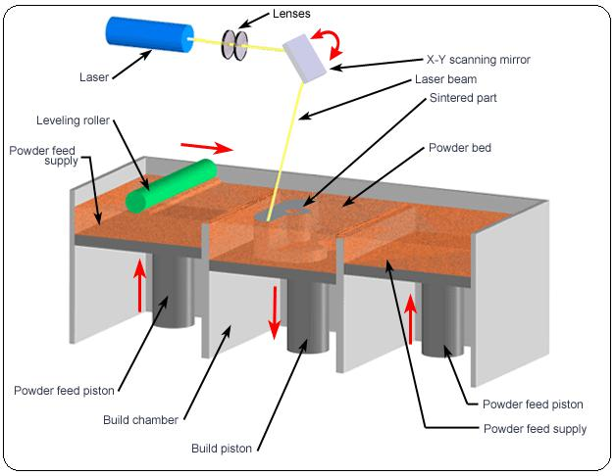

Selective laser sintering uses of a high power laser to fuse small particles of plastic, metal, ceramic, or glass powders into a shape that has a desired geometry. The laser successively fuses powder by scanning cross-sections generated from slicing of STL file on the surface of a powder bed. After each cross-section is scanned, the powder bed is lowered by a distance equal to layer resolution, a new layer of material is applied on top, and the process is repeated until whole object is printed.

3D printer based on this technique typically uses a pulsed laser, it helps in customizing density of printed part. The Selective Laser Sintering machine preheats the powder material inside bed slightly below its melting point, so that it will be easier for laser to heat the material of selected regions above melting point.

This technique is used in many industries due to its capacity of easily making complex objects little human intervention. Its most common application is in prototype parts early in the design cycle such as for investment casting patterns, automotive hardware, and wind tunnel models. SLS is also increasingly being used in limited-run manufacturing to produce end-use parts for aerospace, military, medical, pharmaceutical and electronics hardware. On a shop floor, SLS can be used for rapid manufacturing of tooling, jigs, and fixtures.

18 | P a g e
Laser engineered net shaping
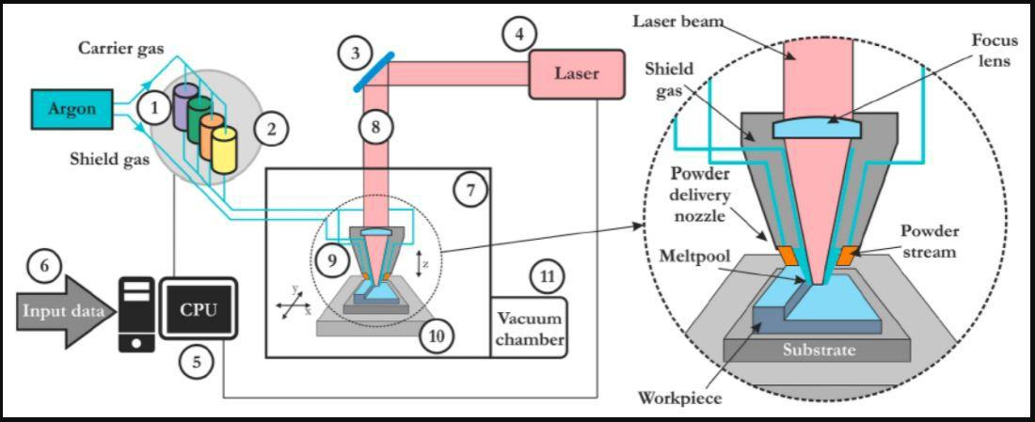

In Laser engineered net shaping also known as direct laser metal deposition component is manufactured by supplying metal powder through nozzle injection and a high power laser beam to melt and deposit over a build platform in a layer-by-layer manner. After printing each layer, the build plate moves down by layer thickness. This process repeats until whole part is printed. This technique was developed to print complex geometry shapes, but it is also good for repair of damaged components and structures.

Nozzles direct flow of metal powder at a central point beneath them. Simultaneously, that point is heated by laser beam having high energy density. The laser and jets remain stationary while the model and its substrate are moved to provide new targets on which to deposit metal continually, as shown in Figure. First, this is done on a substrate, and then on the built up layers, until the desired cross-sectional geometry is completed with production of a 3D metal product. This is a complicated operation because high temperatures make it difficult to form accurate, smooth objects from molten metals. The technology can be used with a wide variety of metals including titanium, steels, copper, and aluminium.

19 | P a g e
Three dimensional powder binding
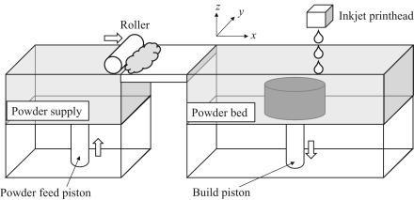

This is powder bed and printing head 3D printing system. It is a process in which a liquid binder is jetted on layers of powdered materials, selectively joined, and then followed by densification process. The layers of the print are bonded together, resulting in a box of powder with binder arranged in the 3D shape of the desired part geometry. The box may then be heated to cure or “set” the binder if needed, and then the printed part(s) may be removed from the powder bed in a process called depowering. This is useful in rapid production of complex structures to achieve isotropic properties in the 3D printed samples. It can produce prototypes in which material properties and surface finish are similar to those attained with traditional powder metallurgy.

20 | P a g e
Advantages and limitations
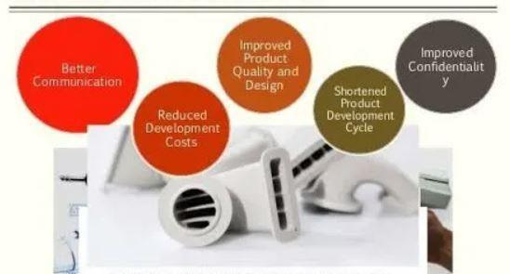

Without rapid prototyping, engineers had to work on a project for months and even years, just to find out at the end that their design was flawed or wasn't good enough, rapid prototyping came to the rescue and saved time, money and above all, it saved emotional investment of the young enthusiasts who were trying to bring something new to the market.

In this fast-moving modern-day consumer market, companies need to develop and introduce new products faster to remain competitive. Since faster product development and technology innovation are key to a company’s success, rapid prototyping becomes the most important element of new product development.

Advantages of rapid prototyping
- Reduced design & development time

- Reduced overall product development cost

- Elimination or reduction of risk

- Allows functionality testing

- Improved and increased user involvement

- Ability to evaluate human factors and ergonomics

21 | P a g e

Like any manufacturing process or design stage, prototyping and rapid prototyping have their own limitations.

Limitations of rapid prototyping

- Lack of accuracy

- Added initial costs

- Some rapid prototyping processes are still expensive and not economical

- Material properties like surface finish and strength cannot be matched

- Requires skilled labour

- The range of materials that can be used is limited

- Overlooking some key features because they cannot be prototyped

- End-user confusion, customers mistaking it for the finished project/developer misunderstanding of user objectives

Anyhow, the benefits of 3D printing outweigh the limitations making the rapid prototyping process cost-effective, time-saving and profitable.

22 | P a g e
Applications of 3D printing
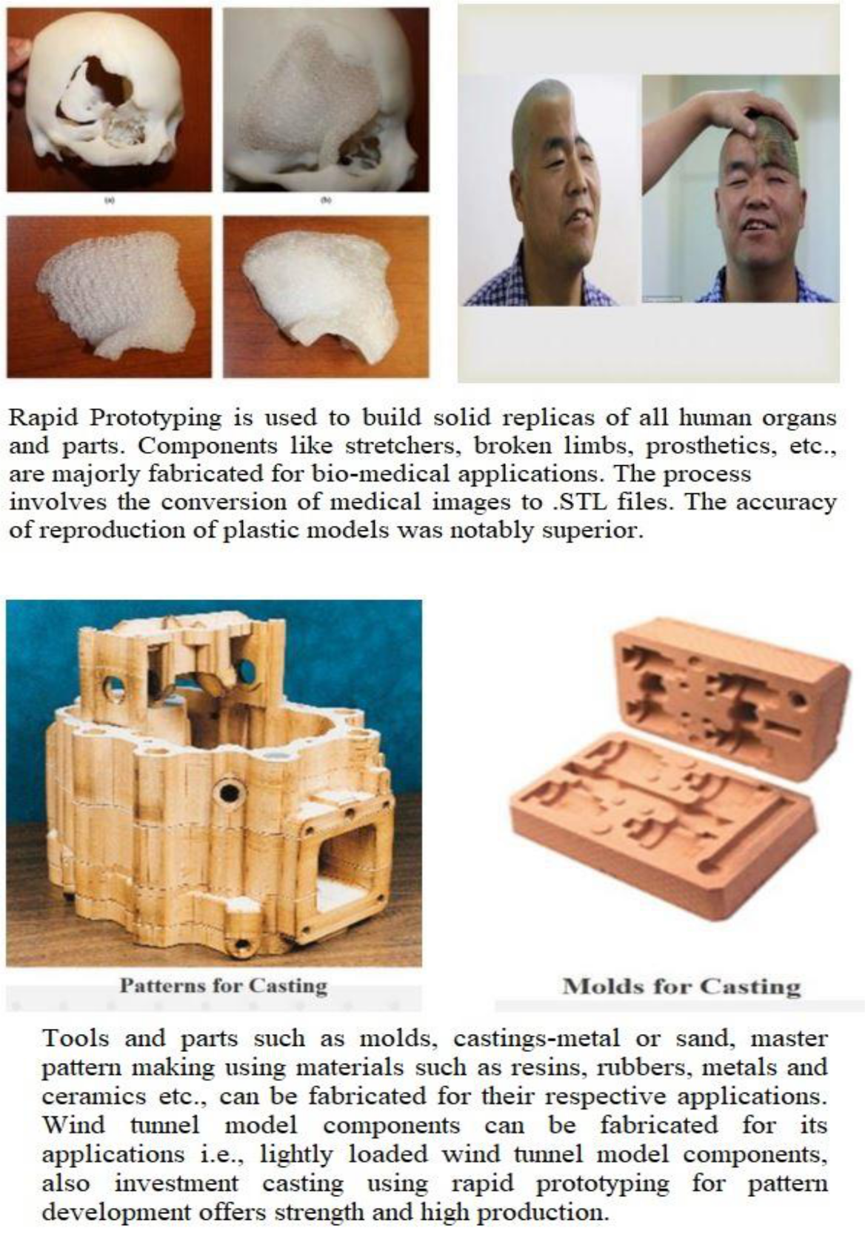

23 | P a g e
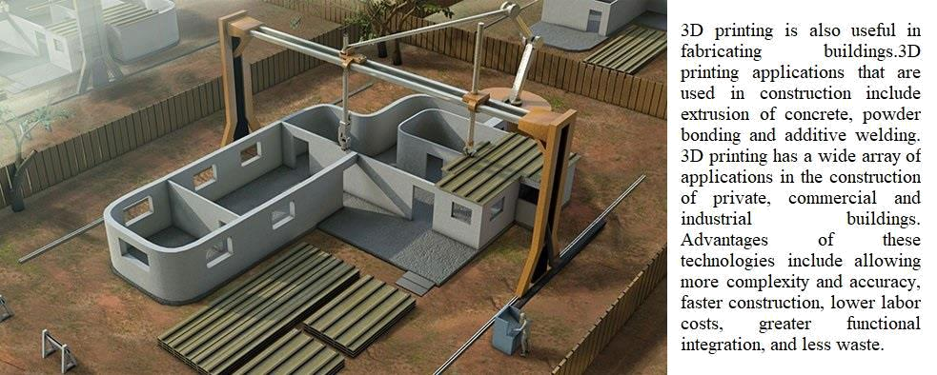

One widely useful of 3D printing is in the replacement parts industry. Main reason for this is that parts can be printed on demand without the need for storing them as an inventory in a storage house. In addition, if a part is no longer manufactured, the replacement can be designed and printed easily, compared to other production processes. The replacement parts industry is undergoing tremendous change because of additive manufacturing. One is now able to simply download from online library and print a replacement part on 3D printer.
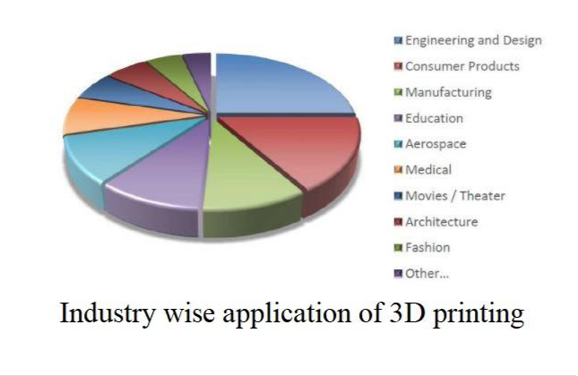

24 | P a g e
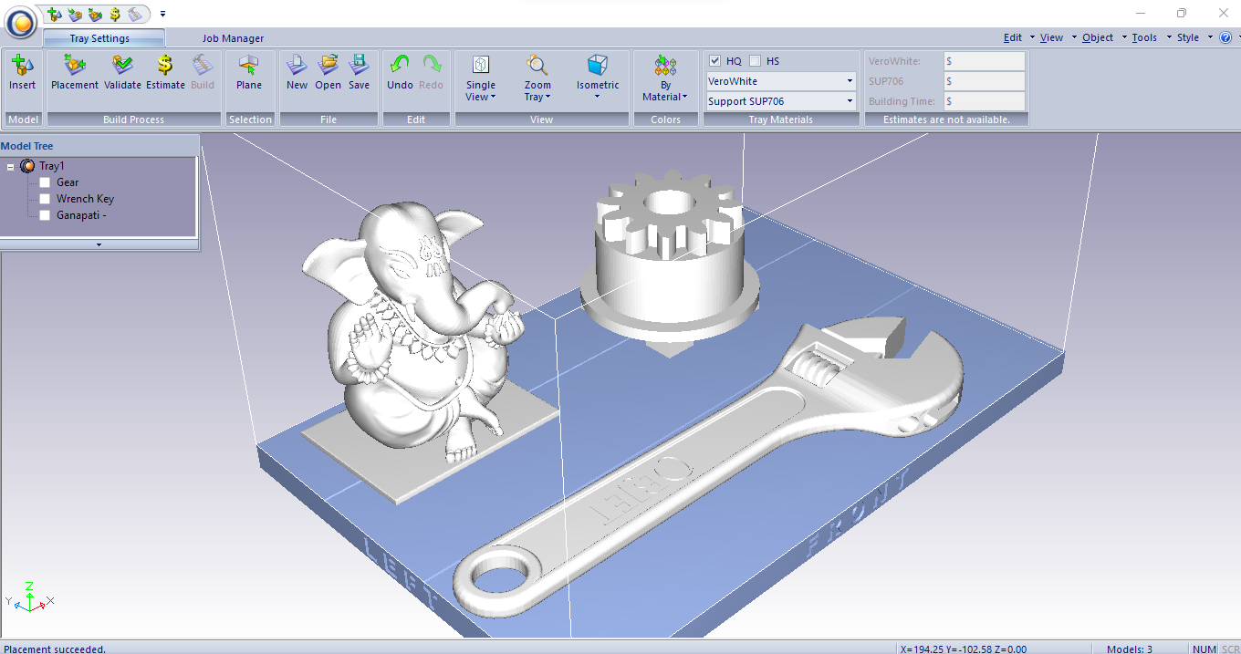
Introduction to objet studio software

To handle STL file and divide into number of layers special 3D printing software is required. Many software’s are available in market. Objet studio is one such application.

It is developed by Objet 3D printing systems. Objet Studio supports STL and SLC files from any 3D CAD modelling application. The software offers simple “click & build” preparation and 3D print tray editing and provides easy, accurate job estimation and full job control, including queue management. The software also features powerful wizards that facilitate and speed up system maintenance.

Key Advantages of Objet Studio software includes:

- Automatic support generation

- Networking capability supports multiple users

- Easy tray builds save setup time

- Slice-on-the-fly dramatically reduces pre-print time

- Auto-placement of parts ensures accurate and consistent positioning

- Intuitive, wizard-guided maintenance provides high up-time

25 | P a g e
Objet 30 prime 3D printer

The Objet30 3D printer developed by stratasys corporation provides accurate and versatile 3D printing - all from your desktop. With excellent print resolution, the Objet30 lets you create single material parts with smooth surfaces, small moving parts, and details like thin walls. The roomy tray size provides the versatility for a variety of consumer goods, electronics, medical devices and more. The Objet30 also provides a user-friendly workflow, so you can get printing faster and manage print jobs with ease.
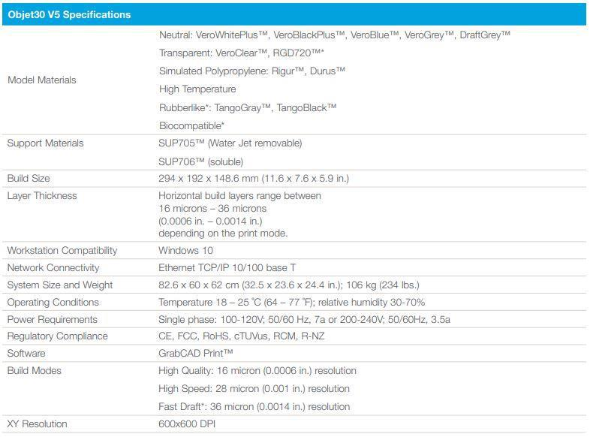

26 | P a g e

